HYPERLANE
Changes & UI Design · v2.4 · for team review

This is a short companion document, not the full design doc. It carries only what changed since GDD v2.3, plus the complete UI screen set. Read it alongside the GDD — anything not mentioned here is unchanged. The last section lists name options for us to choose from.

1. What changed since v2.3

Area | Change
Playfield | The lane is now five lanes wide. This changes how the lethal hazards work.
Controls | All-gesture scheme defined: swipe up to jump, swipe down for the signature ability, tap for the utility ability, tap or swipe sideways to change lane.
Lethal hazards | Each lethal is now a spatial puzzle with exactly one safe spot. The matched class ignores the puzzle entirely.
Leaderboards | Confirmed: two boards, and they do not collapse into one now that speed is equal. Distance and chain measure different things.
UI | A full screen set is specified for the first time — nineteen screens, in Section 5.

2. Controls

One control scheme for all three classes. Nothing is class-specific except which ability each gesture fires. The scheme is all-gesture: no on-screen ability buttons cluttering the lane.
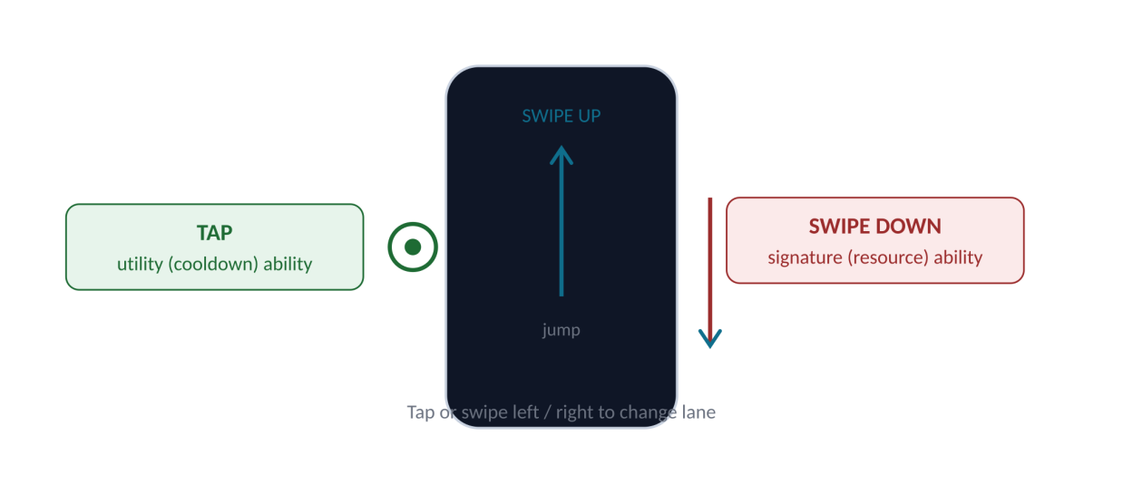
The four inputs. The same gesture fires a different ability depending on the class.
Input | Does | Mach | Brute | Lynn
Swipe up | Jump | Jump | Jump | Jump
Swipe down | Signature ability | Surge Jump | Smash | Full Heal
Tap | Utility ability | Blink | Shock Wave | Shield Pulse
Tap / swipe side | Change lane | — | — | —
Why swipe-down for the signature and tap for the utility: a signature move is a committed, deliberate action, so it gets a deliberate gesture. The utility is a quick reflex, so it gets the quickest input — a tap. Jump stays the most instinctive motion, swipe up. Nothing is overloaded; every input is its own distinct motion.

3. Five lanes and the lethal puzzles

The lane is five across. Each lethal hazard blocks most of them and leaves exactly one safe spot. Every class must reach that spot — except the one class matched to the hazard, which ignores the puzzle completely.
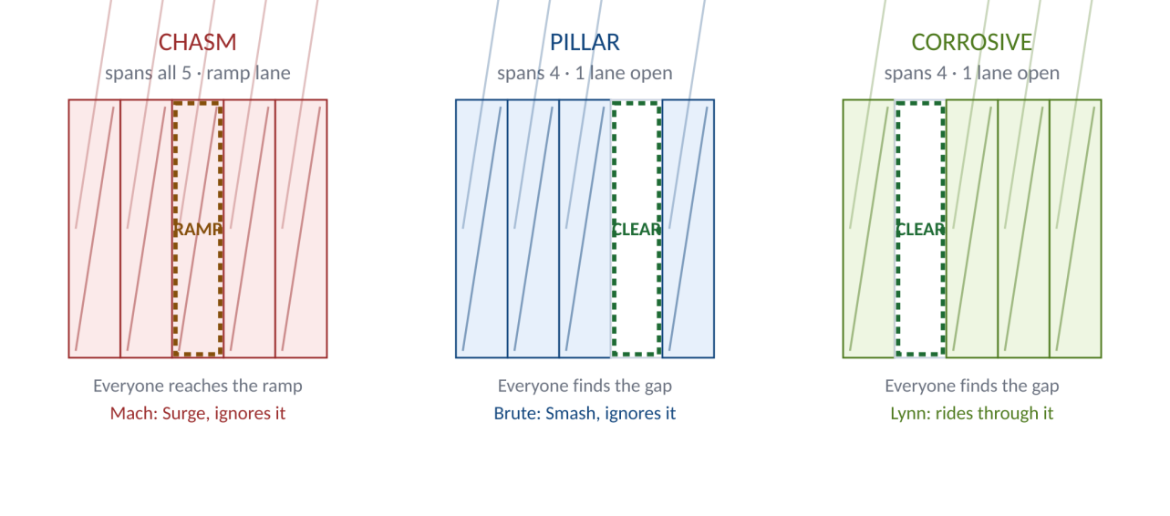
The three lethals on five lanes. Dashed lane is the safe spot; the matched class skips it.
Lethal | Spans | Safe spot | Everyone reaches it by | Matched class ignores it
Chasm | All 5 lanes | 1 ramp lane | Steering to the ramp and jumping | Mach — Surge Jump clears it anywhere
Pillar (lethal blockade) | 4 lanes | 1 open lane | Steering into the open lane | Brute — Smash destroys it in any lane
Corrosive Spill | 4 lanes | 1 open lane | Steering into the open lane | Lynn — rides through it in any lane
All three lethals are now the same shape: one safe spot, reached by steering, ignored only by the matched class. This makes them symmetric and fair — each class is master of exactly one, mortal to the other two — and it gives every class a moment where its identity saves its life.
- The safe spot is randomised each time, so players read the lane rather than memorising a position.
- Telegraphs are unchanged: 1.5s marker, audio cue and edge flash before every lethal. No lethal ever kills without warning.
- The pillar was widened from 3 lanes to 4 during design, so that dodging it is a real decision rather than a trivial side-step, and so Brute’s Smash stays meaningful.

4. Leaderboards, reconfirmed

With every class now at the same speed, it was worth checking whether the two leaderboards collapse into one. They do not. They measure genuinely different things.
Board | Ranks on | Rewards | Pool
Class boards (×3) | Distance survived | Endurance — living long | Per class, so cross-class balance is irrelevant
Open board | Chain score | Skill — never getting touched | All classes together
A player can travel far with a broken chain (high distance, low score) or die early with a perfect one (low distance, high score). Because those two outcomes come apart, the two boards stay distinct and both earn their place.

5. UI Design — the full screen set

Nineteen screens, grouped by flow. These are wireframes: layout, hierarchy and copy are fixed; the visual polish is the UI/UX team’s to own. Every dashed box is an art zone for the illustrator to fill.
Legend | Meaning
Solid border | Final UI element — build it as drawn
Dashed border | Art zone — illustration goes here
Colour | Red Dasher · Blue Bulwark · Green Healer · Cyan brand · Amber coins/warning · Violet prestige

5.1 Boot and entry
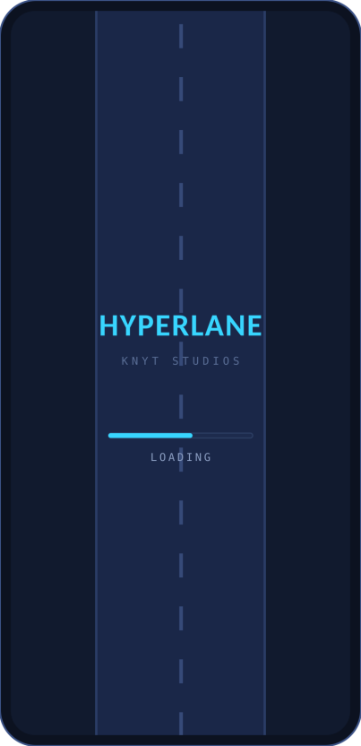  Splash / Loading  - Wordmark over the lane backdrop.  - A loading bar, nothing else.  - Sets the visual tone in one screen. | 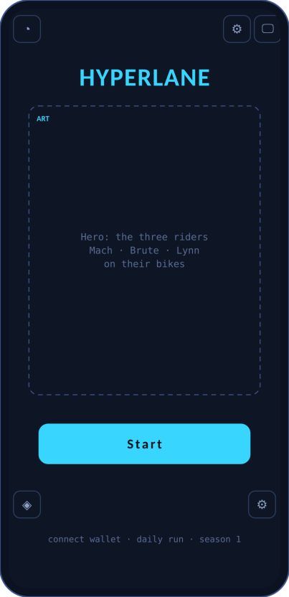  Home  - The three-rider hero is the studio showcase.  - Start is the only primary button.  - Corner icons: profile, settings, wallet, utilities.
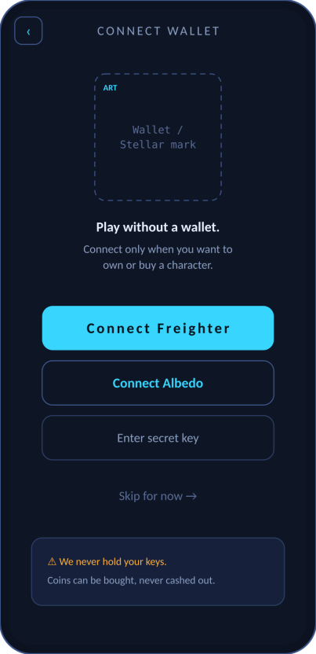  Connect Wallet  - Freighter and Albedo are the Stellar wallet options.  - “Skip for now” is always available — play needs no wallet.  - Footer restates: we never hold keys; coins never cash out. | 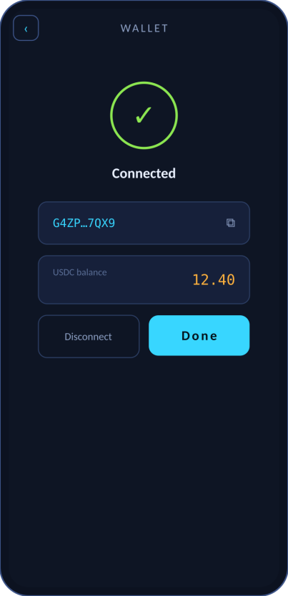  Wallet Connected  - Shows truncated address and USDC balance.  - Copy-address affordance.  - Disconnect sits beside Done.

5.2 Choosing a run
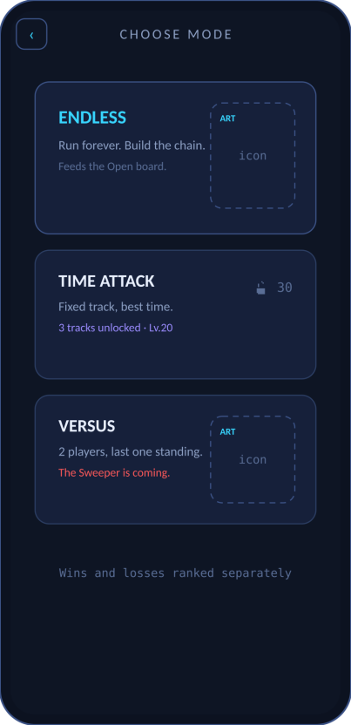  Mode Select  - Endless is the headline mode.  - Time Attack shows its level-gated track count.  - Versus flags the Sweeper as upcoming. | 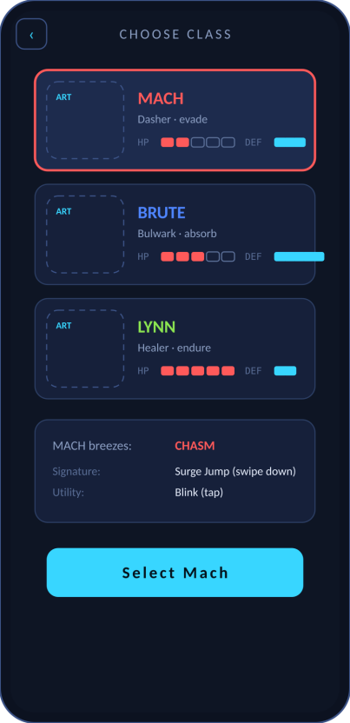  Class Select  - Three class cards with HP/DEF pips.  - Selected card expands with its kit and which lethal it breezes.  - Signature and utility inputs are stated here.
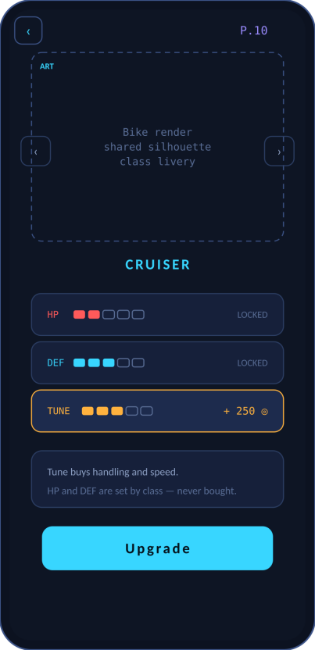  Garage  - Bike carousel — one silhouette, class livery.  - HP and DEF shown but marked LOCKED — the pay-to-win firewall, made visible.  - Only TUNE (handling/speed) spends coins. | 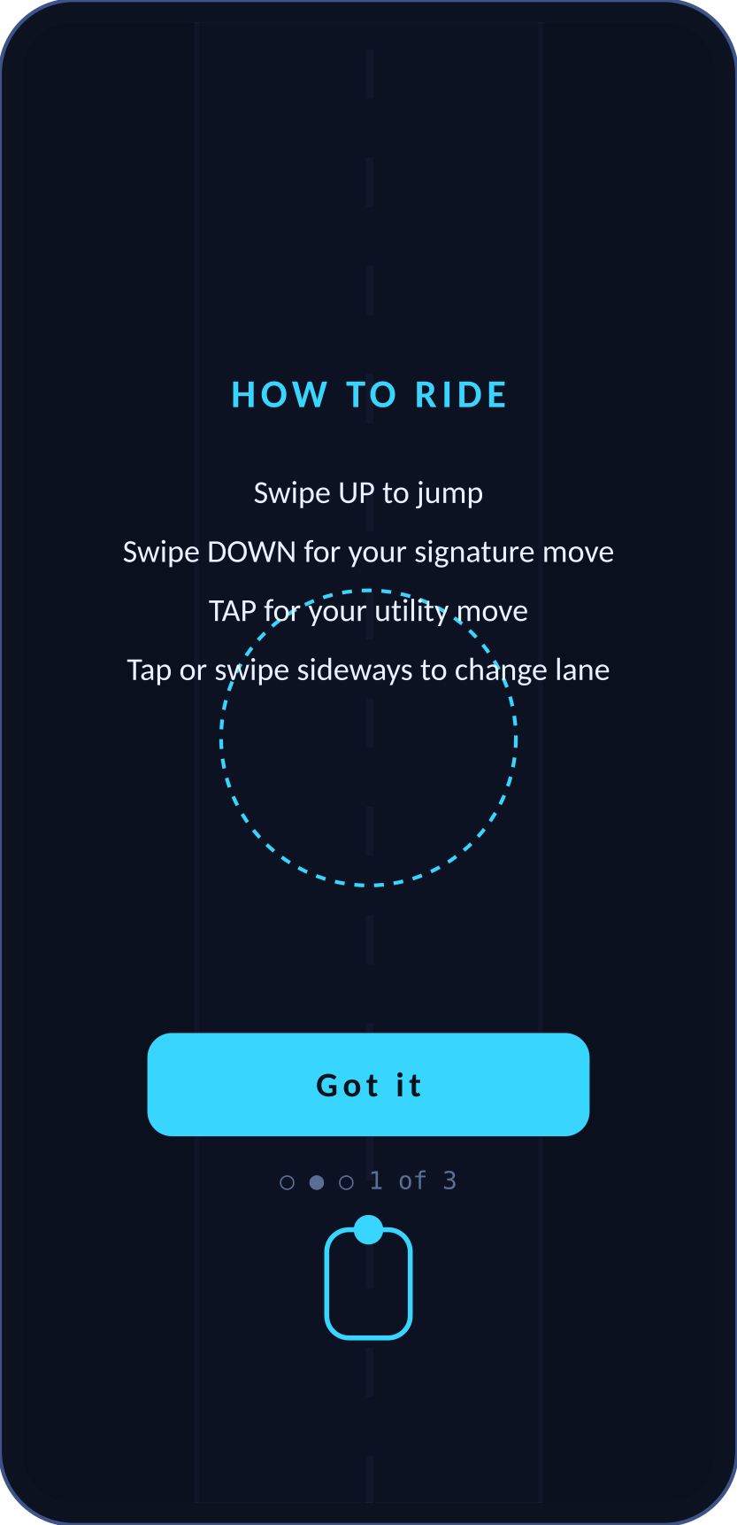  First-Run Onboarding  - Teaches the four gestures over a dimmed lane.  - Three short cards, skippable.  - Only shown on first launch.

5.3 In-run HUD
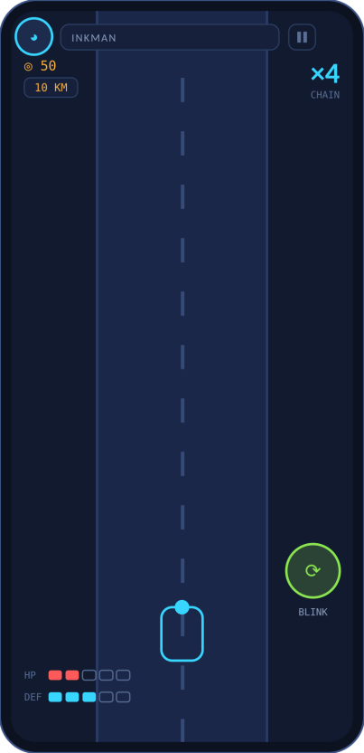  Base HUD  - Top-left: avatar, name, coins, distance.  - Top-right: the chain multiplier, large — it is the score.  - Bottom-left: HP/DEF pips. Utility button lower-right. | 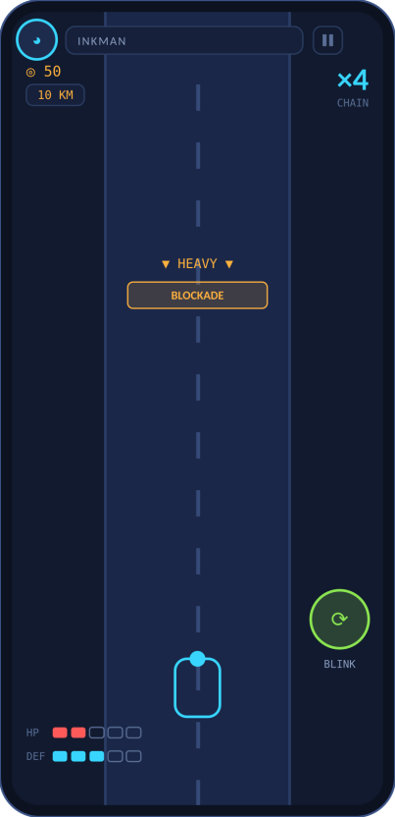  Heavy Hazard  - Amber telegraph band, 0.75s before contact.  - Class-neutral: jump, smash, or tank.  - One wall art, three different responses.
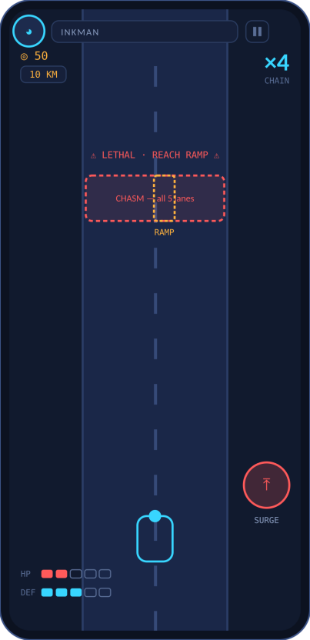  Lethal · Chasm  - Red lethal telegraph, 1.5s + audio + edge flash.  - Ramp lane marked amber — the safe spot.  - Signature button shows SURGE for Mach. | 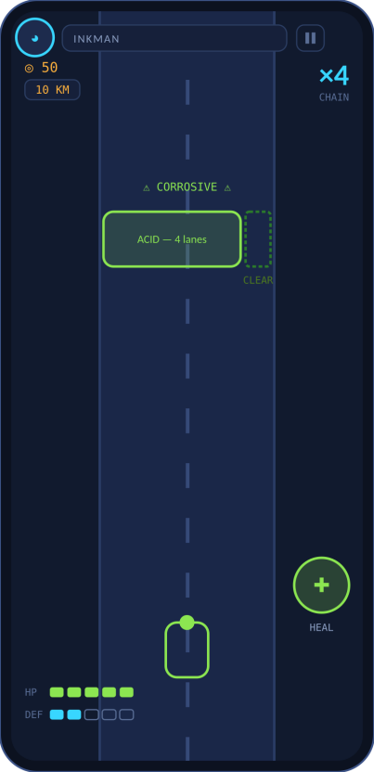  Lethal · Corrosive  - Lime telegraph and glyph — distinct silhouette from the chasm.  - One clear lane marked green.  - Lynn’s HP/DEF pips and green rider show the matched class.
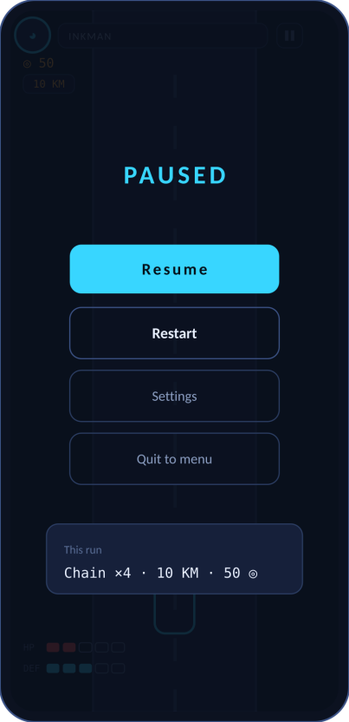  Pause Overlay  - Dims the lane, freezes the run.  - Resume, Restart, Settings, Quit.  - Shows the current run’s chain, distance and coins. | (Ability-ready state)  - When a resource bar is full, the signature glyph lights in class colour.  - A quick pulse cues the player it is ready.  - Reuse the HUD; only the button state changes.

5.4 After the run
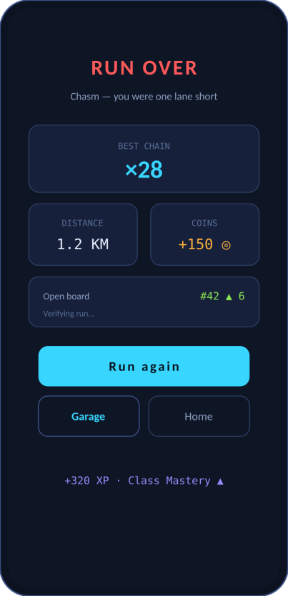  Run Over  - Best chain is the hero figure.  - Distance and coins earned beside it.  - Board movement and “verifying run…” while the server checks.  - XP and Class Mastery progress at the foot. | 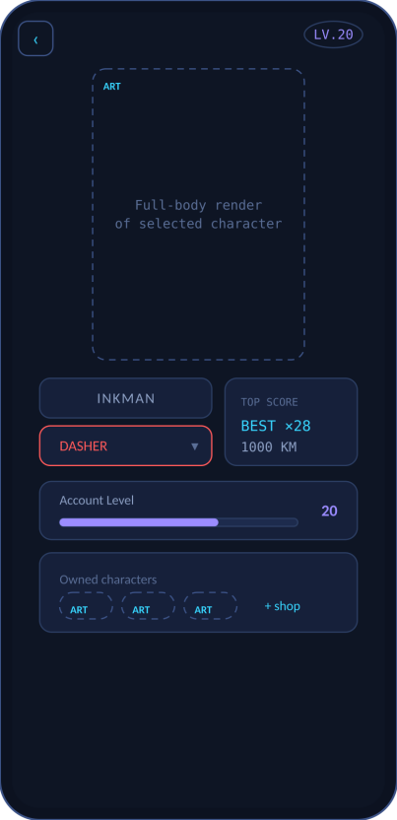  Profile  - Level badge top-right — prestige, shown everywhere.  - Character render zone for the owned skin.  - Class dropdown, top scores, owned-character strip.

5.5 Meta and economy
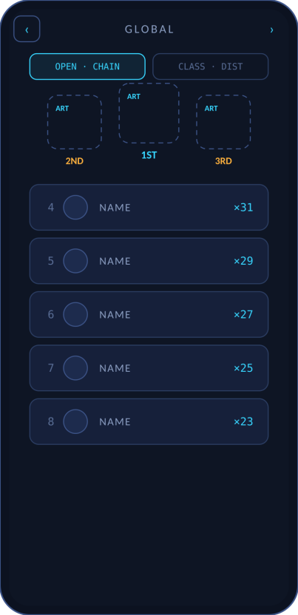  Leaderboard  - Toggle: Open (chain, pooled) vs Class (distance).  - Podium for top three, winner centred.  - Score column shows the multiplier on Open. | 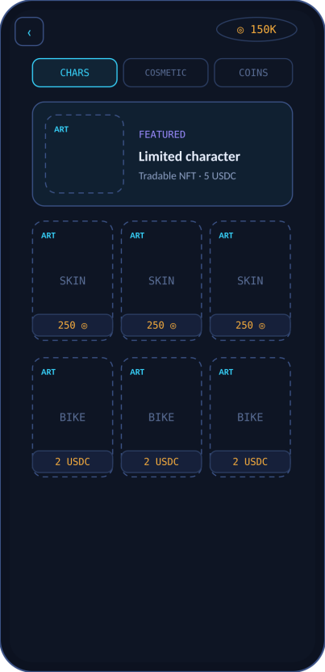  Shop  - Tabs: Characters (NFT), Cosmetic, Coins.  - One featured slot, then a thumbnail grid.  - Coin balance always visible; prices in coins or USDC.
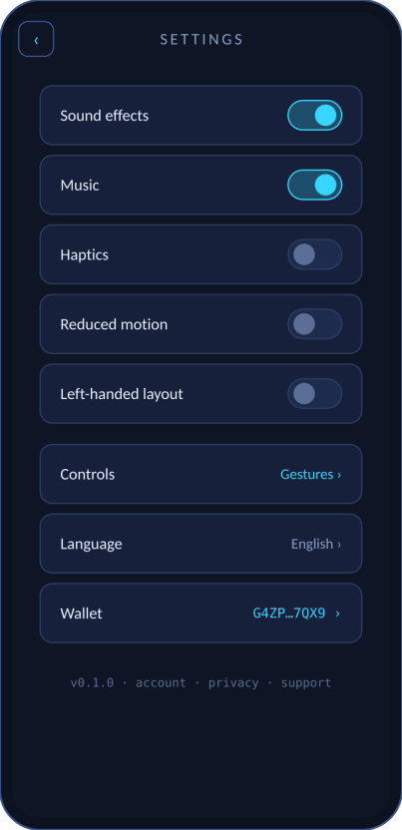  Settings  - Sound, music, haptics, reduced motion, handedness.  - Controls, language, and wallet management.  - Version and legal links at the foot. | 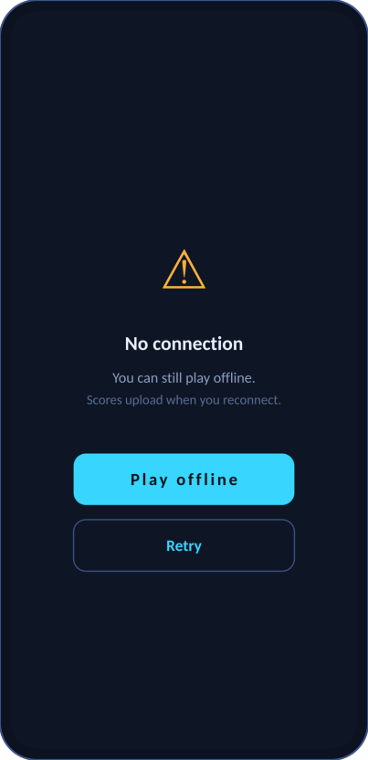  Offline / Error  - Play continues offline; scores upload on reconnect.  - Clear retry.  - Same pattern for any recoverable error.

6. Four rules for the UI team

- HP and DEF are always pips, never numbers. A player reads bars at speed; they cannot read digits.
- The chain multiplier is the dominant in-run figure. It is the score. Nothing on the HUD competes with it for size.
- Telegraph colours are fixed. Amber heavy, red lethal, lime corrosive. These never mean anything else, anywhere.
- Dashed boxes are the illustrator’s. Everything else is the UI designer’s. Keep the seam clean.

7. The name — options to choose from

“Hyperlane” collides with an established blockchain interoperability protocol. Since our game also settles on Stellar, that is a same-industry clash: search confusion, a taken domain and org, and a trademark question later. We should pick a new name before registering anything. Options below, grouped by feel — this is for the group to react to, not a final call.

Speed and motion
Name | Why it fits | Watch for
SLIPSTREAM | Racing term; ties to Mach’s near-miss passive | Somewhat common word
REDLINE | Engine at its limit; danger and speed in one word | Used by other games — check
VELOCITÉ | Velocity with an edge; distinctive spelling | Accent may complicate domains
HURTLE | Fast, reckless motion; short and punchy | Sounds like “hurdle” aloud

The lane and the run
Name | Why it fits | Watch for
DEADLANE | The hostile lane, stated plainly; dark and memorable | “Dead” may read grim for some audiences
LANEBREAK | Breaking through the lane; motion and rupture | Slightly generic
THE GAUNTLET | A run through danger; strong and known | Very common title — likely taken
THROUGHLINE | The clean line through hazards; doubles as “staying alive” | Softer, less arcade

Invented / ownable
Name | Why it fits | Watch for
KYRO | Short, coined, easy domain and trademark | Meaning is blank until we build it
VAYLINE | “Via” + line; a coined route word | Could read soft
NYX RUN | Night-run; pairs with a dark neon look | Two words; “Nyx” is used elsewhere
ZERANE | Fully invented; distinctive and search-clean | No inherent meaning
Recommended shortlist to react to first: SLIPSTREAM (meaning + ties to a real mechanic), DEADLANE (memorable, on-theme), and KYRO (fully ownable). Whichever we pick, check the .xyz domain, the GitHub org, app-store names, and a quick trademark search before we commit. Tell me the choice and I’ll thread it through every document.

Everything here is a proposal for the group. Layout and mechanics are settled in the GDD; the name is open. Bring reactions and we’ll lock v2.4 into the main documents.

